Distribution in Statistics & Machine Learning
What is Distribution?
Distribution refers to the arrangement or spread of values in a dataset.
It shows:
- How data is spread
- Which values occur most frequently
- Whether data is symmetric or skewed
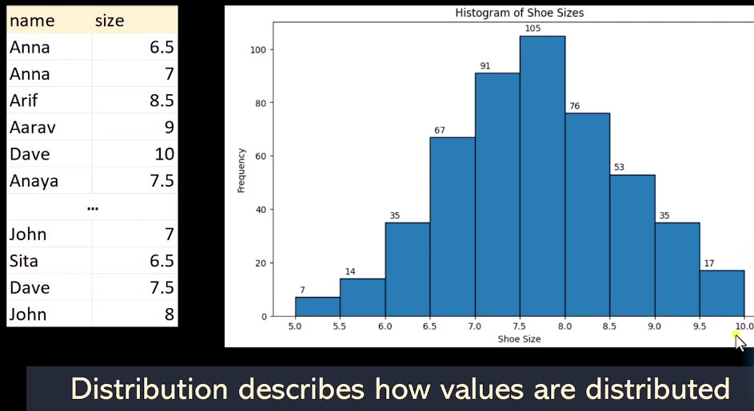

Empirical Distribution
Definition
An Empirical Distribution is a probability distribution created directly from observed data instead of using a theoretical formula.
It represents:
- Real collected data
- Actual frequencies of observations
- Approximation of the true distribution

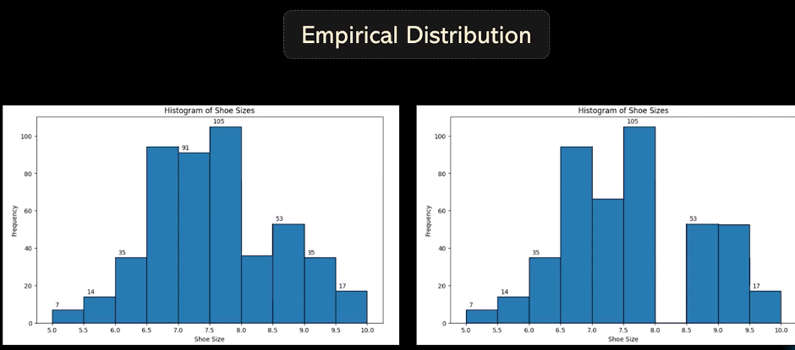
1. Normal Distribution
A Normal Distribution is a probability distribution where:
- Most values are clustered around the center
- Fewer values occur near extremes
- Shape looks like a bell curve
It is also called:
- Gaussian Distribution
- Bell-shaped curve

Diagram of Normal Distribution
Mean
|
.-''''''-.
.-' '-.
.' '.
---------.'--------------------'.---------
Properties
- Symmetric around mean
- Mean = Median = Mode
- Most natural data follows this pattern

Examples
- Human height
- IQ scores
- Exam marks
- Measurement errors

Probability Distribution
A probability distribution shows the likelihood of different outcomes.
It tells:
- Which outcomes are possible
- How probable each outcome is

Example
Rolling a fair dice:
Outcome | Probability
1 | 1/6
2 | 1/6
3 | 1/6
4 | 1/6
5 | 1/6
6 | 1/6
Total probability = 1

Types of Probability Distribution
There are mainly two types:
- Discrete Distribution
- Continuous Distribution

2. Discrete Distribution
In a discrete distribution:
- Values occur in separate/countable steps
- No intermediate values exist
Examples:
- Number of students
- Number of cars
- Dice outcomes

Diagram
Probability
|
0.4| |¯|
0.3| |¯| | |
0.2| | | | |
0.1|___|_|_|_|____
1 2 3 4
Values occur only at specific points.

Characteristics
- Countable values
- Finite or countably infinite
- Uses Probability Mass Function (PMF)

Example
Number of heads when tossing 3 coins.
Possible values:
0, 1, 2, 3

3. Continuous Distribution
In continuous distribution:
- Values can occur anywhere within a range
- Infinite possible values exist
Examples:
- Height
- Weight
- Temperature
- Time

Diagram
Probability
|
| /\
| / \
| / \
___|______/____________\______
Smooth curve because values are continuous.

Characteristics
- Infinite possible values
- Measured values
- Uses Probability Density Function (PDF)

Difference Between Discrete and Continuous Distribution
Feature | Discrete | Continuous
Values | Countable | Infinite
Example | Dice numbers | Height
Graph | Bars | Smooth curve
Function | PMF | PDF

Important Formula
Normal Distribution Formula:
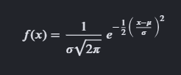
Why Distributions Matter in Machine Learning
Distributions help in:
- Understanding data behavior
- Detecting outliers
- Feature engineering
- Data preprocessing
- Choosing ML algorithms
Many ML models assume data follows normal distribution.

Quick Revision Notes
Concept | Meaning
Distribution | Spread of data
Normal Distribution | Bell-shaped symmetric curve
Probability Distribution | Likelihood of outcomes
Discrete Distribution | Countable separate values
Continuous Distribution | Infinite measurable values

Viva / Interview Questions
Q1. What is a distribution?
Arrangement or spread of values in data.
Q2. What is normal distribution?
A symmetric bell-shaped probability distribution.
Q3. Give examples of discrete distribution.
Dice outcomes, number of students.
Q4. Give examples of continuous distribution.
Height, weight, temperature.
Q5. Difference between discrete and continuous distribution?
Discrete has countable values; continuous has infinite measurable values.

